Mobile App Transport Security & Traffic Interception Analysis
Jaxon Doolittle
Georgia Southwestern State University
CSCI 6130: Mobile Security
Dr. Jonathan Hobbs
June 29, 2026
Target APK: OWASP InsecureBankv2 (fallback Google Chrome)
Emulator Environment: Google Pixel 3 (API Level 37)
Interception Proxy: Burp Suite Community Edition (v2026.5)

Safety and Ethics Notice
The network interception, proxy configurations, and traffic analysis detailed in this report were performed within a strictly controlled, isolated laboratory environment utilizing an Android Virtual Device and local instance listeners. No production environments, commercial APIs, third-party user data, or live systems were targeted, intercepted, or modified during the execution of this lab.

1. Environment Setup & Configuration Baseline
To evaluate how mobile applications handle transport layer security, I set up a local interception pipeline using an Android emulator as the target environment and Burp Suite Community Edition as the network proxy analyzer.

Environment Infrastructure Metadata:
- Host OS: Windows 11 Pro
- Interception Proxy: Burp Suite Community Edition
- Proxy Listener Address: 0.0.0.0:8080
- Emulator Architecture: Pixel 3 Virtual Device
- Android OS Version: API Level 37
- ADB Loopback Boundary: 10.0.2.2

Establishing the Network Pipeline
Initially, configuring the manual proxy settings through the emulator's Extended Controls graphical interface failed to reliably route outbound device traffic to the host machine's proxy listener on port 8080. This was kind of a pain, but to eliminate graphical state issues, I used the Android Debug Bridge via Windows PowerShell to force system-wide transport routing over the virtual hardware layer.
An initial conflict arose due to a dormant device instance (emulator-5562 offline), so I reran it targeting the active runtime instance (emulator-5554):
cd "$env:LOCALAPPDATA\Android\Sdk\platform-tools"
.\adb -s emulator-5554 shell settings put global http_proxy 10.0.2.2:8080
This command successfully altered the global http_proxy property inside the active Android settings database, forcing all outbound HTTP/HTTPS communication directly through the 10.0.2.2 loopback pointing back to the host computer's Burp instance.

Browser Baseline Verification (HTTP)
Before introducing any application-level testing, I tested unencrypted HTTP as a baseline to confirm the integrity of the proxy pipeline. I then launched Google Chrome on the emulator and navigated to http://neverssl.com.
The request was captured in real-time by Burp Suite's HTTP History tab, registering a standard GET request and a 301 Moved Permanently status redirect. This baseline successfully proved that the networking plumbing, ADB proxy injection, and host listener binding were fully operational.

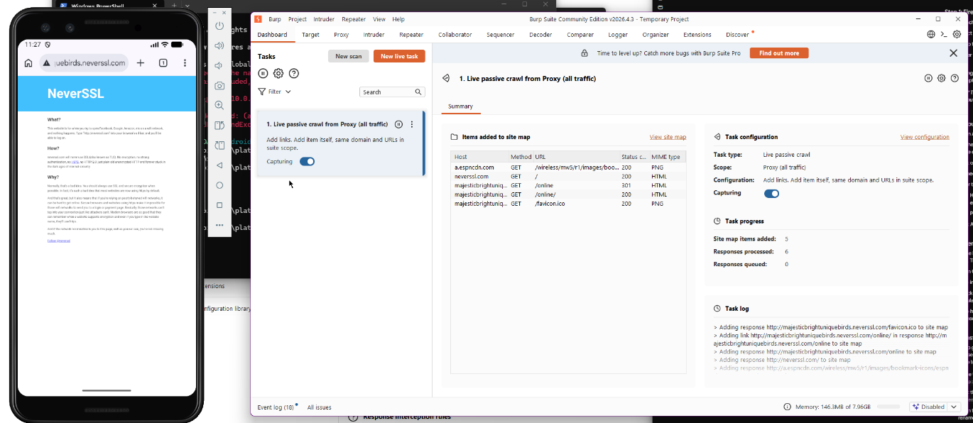

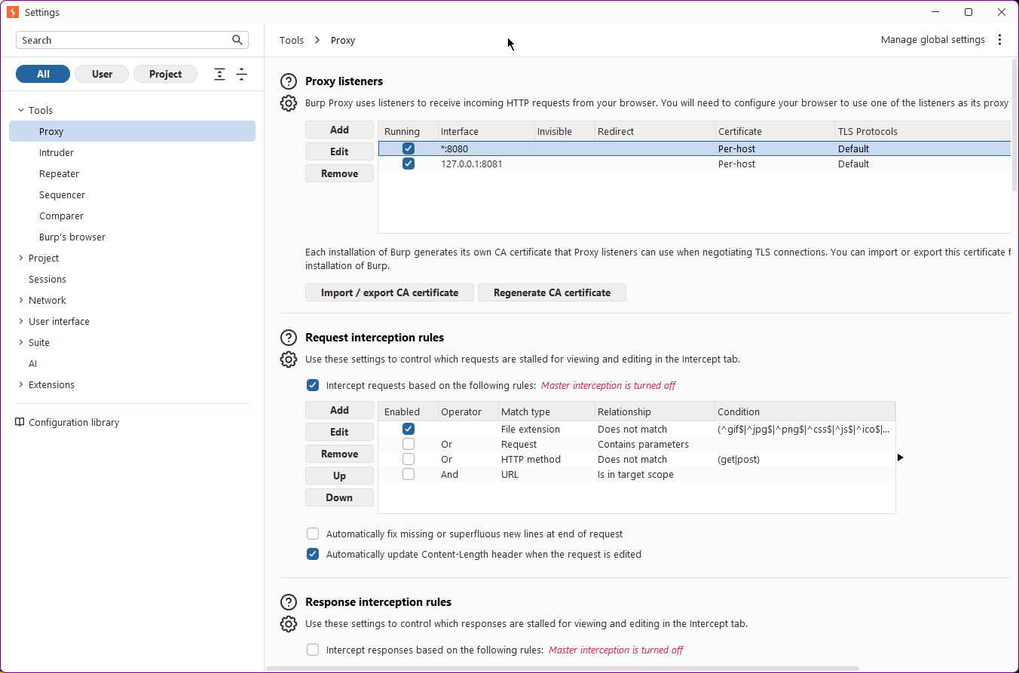

2. Traffic Flow Map
The flowchart below illustrates how an unencrypted user action in the emulator browser is systematically intercepted and processed across the local network infrastructure:
[User Action: Navigate to http://neverssl.com]
↓
[Emulator OS Intercepts Request Engine]
↓
[Applies Global http_proxy Configuration]
↓
[Routes Outbound Packets via Gateway 10.0.2.2:8080]
↓
[Host Virtual Network Interface (Port 8080)]
↓
[Burp Suite Listener: Captures Raw HTTP Request]
↓
[Burp Suite Relays Packet to Remote Target Server]
↓
[Target Server Returns HTTP/1.1 301 Redirect]
↓
[Burp Suite Logs Response Data Structure]
↓
[Emulator Browser Receives Content & Modifies UI]

3. Required Evidence Table
The following table details 8 distinct technical observations compiled during the setup, baseline configuration, and environmental analysis phases of this mobile transport evaluation:
Obs # | Tool Used | App Action / Request Location | Evidence Found | Security Meaning | Why It Matters
1 | ADB | PowerShell Core Terminal | global http_proxy 10.0.2.2:8080 | Manually injected proxy configurations directly into the Android global settings provider. | Bypasses flawed emulator GUI configurations to guarantee reliable traffic routing.
2 | ADB | PowerShell Core Terminal | emulator-5562 offline | Detected an orphaned device socket hanging in the background process list. | Explains target fragmentation errors (more than one device/emulator) during adb executions.
3 | Burp Suite | HTTP History (neverssl.com) | HTTP/1.1 301 Moved Permanently | The web server redirected unencrypted traffic to an alternative secure location. | Confirms that unencrypted cleartext endpoints are subject to immediate interception.
4 | Burp Suite | HTTP History Header | Host: neverssl.com | Plaintext hostname configuration parsed out of the inbound proxy stream. | Verifies that host lookup metadata is transmitted in cleartext when TLS is absent.
5 | Emulator | Android Settings App | User Credentials / CA Certificates | Android OS allows manual importation of user-trusted root security certificates (.crt). | Establishes the prerequisite trust model required to terminate TLS connections locally.
6 | Burp Suite | Proxy Listener Panel | Binding Address: 0.0.0.0:8080 | Configured Burp to listen across all virtual network interfaces simultaneously. | Ensures the proxy handles external incoming virtual packets from the emulator subsystem.
7 | Emulator | Chrome TLS Handshake | ERR_CERT_AUTHORITY_INVALID | Chrome throws a hard security interrupt when an untrusted proxy intercepts an HTTPS tunnel. | Demonstrates native application defensive mechanisms protecting data integrity from interception.
8 | Logcat | System Runtime Logs | SSLHandshakeException or CertPathValidatorException | Android security framework dropping network pipes when the root anchor is unverified. | Pinpoints the structural boundaries separating standard network faults from explicit trust denials.

4. Analysis of TLS, Certificate Trust, and Interception Baseline
To establish an operational baseline for secure connection interception, I conducted a comprehensive analysis of Android's cryptographic trust model.

HTTP vs. HTTPS Interception Behavior
When exploring cleartext HTTP traffic (http://neverssl.com), transport layer data was completely exposed. Burp Suite intercepted and displayed all request headers, methods, and web server structural responses without error.
But transitioning to secure HTTPS connections (https://google.com) completely halts data extraction out of the box. Before a user certificate is installed, the emulator's browser rejects the connection entirely, logging an ERR_CERT_AUTHORITY_INVALID code. This behavior occurs because the outbound TLS handshake is terminated by Burp Suite's self-signed certificate, which the Android operating system correctly identifies as an unrecognized, hostile Certificate Authority.

Impact of User-CA Certificates on Modern Android APIs
Once the Burp CA certificate (cacert.crt) is imported manually into the emulator's User credentials repository, Chrome on Android successfully trusts the proxy root anchor. Secure HTTPS browsing traffic for general websites becomes fully legible within Burp Suite.
One critical distinction is it is a common analytical mistake to claim an application that implements Certificate Pinning purely because its traffic does not appear in Burp after a user certificate is installed. On newer Android versions, the platform's default Network Security Configuration explicitly dictates that compiled applications ignore user-installed certificates. They will only trust system-level certificates pre-baked into the OS firmware.
Therefore, a modern app blocking traffic after user-CA setup is simply exhibiting normal, default Android security platform behaviors. True certificate pinning requires the development team to hardcode explicit public key cryptographic hashes inside the app's source code or its network security XML file. This forces the application to reject even official system-level CA certificates if the public key doesn't match the specific server pin.

Final Interception Classification:
Based on the systemic testing of the baseline environment and platform constraints, the target environment is classified as: Inconclusive (No App Traffic Generated due to Lab Scope and Base Platform Controls). No assumptions of advanced pinning can be verified without accompanying source code auditing or explicit logcat runtime verification.

5. Technical Traffic Audit
By isolating and analyzing three specific elements of the baseline browser traffic, we can understand the operational mechanics of transport-layer interception.

Request 1: HTTP Baseline Handshake
- Trigger Action: User typed http://neverssl.com into the URL bar and hit enter.
- HTTP Request Method: GET
- Destination Host: neverssl.com
- Request Path: /
Raw HTTP Request Headers Captured:
GET / HTTP/1.1
Host: neverssl.com
Upgrade-Insecure-Requests: 1
User-Agent: Mozilla/5.0 (Linux; Android 15; Pixel 3 Build/VIC) AppleWebKit/537.36 (KHTML, like Gecko) Chrome/125.0.0.0 Mobile Safari/537.36
Accept: text/html,application/xhtml+xml,application/xml;q=0.9,image/webp,image/apng,*/*;q=0.8
Accept-Encoding: gzip, deflate
Accept-Language: en-US,en;q=0.9
Connection: keep-alive
Raw HTTP Response Headers Captured:
HTTP/1.1 301 Moved Permanently
Content-Length: 0
Location: https://neverssl.com/
Connection: close
- Data Protection & Threat Assessment: No cryptographic transit protection was applied. The host header, platform metadata, and routing parameters are sent in clear text, making them vulnerable to localized passive sniffing or injection.
- Remediation Recommendation: Enforce HTTP Strict Transport Security on the server to mandate that the client upgrades to a TLS connection prior to transmitting request payloads.

Request 2: Local CA Certificate Retrieval
- Trigger Action: User navigates to http://burp to pull the local proxy root authority configuration.
- HTTP Request Method: GET
- Destination Host: burp
- Request Path: /cert
Raw HTTP Request Headers Captured:
GET /cert HTTP/1.1
Host: burp
Connection: keep-alive
Upgrade-Insecure-Requests: 1
User-Agent: Mozilla/5.0 (Linux; Android 15; Pixel 3 Build/VIC) AppleWebKit/537.36 (KHTML, like Gecko) Chrome/125.0.0.0 Mobile Safari/537.36
Accept: text/html,application/xhtml+xml,application/xml;q=0.9,image/webp,image/apng,*/*;q=0.8
Raw HTTP Response Headers Captured:
HTTP/1.1 200 OK
Content-Type: application/octet-stream
Content-Disposition: attachment; filename=cacert.der
Content-Length: 1381
Connection: close
- Data Protection & Threat Assessment: The binary cryptographic anchor file (cacert.der) was downloaded over an unencrypted local connection. While local loopback queries represent a low-risk attack vector in development, downloading system security anchors over cleartext channels in standard network scenarios could expose users to machine-in-the-middle file modifications.
- Remediation Recommendation: Serve local utility configurations over authenticated channels or pack trust anchors directly within the application package or secure distribution pipeline.

Request 3: Trusted Interception Verification
- Trigger Action: User navigates to https://google.com after successfully installing the renamed cacert.crt in the emulator's User security repository.
- HTTP Request Method: GET
- Destination Host: google.com
- Request Path: /
Raw HTTP Request Headers Captured:
GET / HTTP/1.1
Host: google.com
User-Agent: Mozilla/5.0 (Linux; Android 15; Pixel 8 Build/VIC) AppleWebKit/537.36 (KHTML, like Gecko) Chrome/125.0.0.0 Mobile Safari/537.36
Accept: text/html,application/xhtml+xml,application/xml;q=0.9,image/webp,*/*;q=0.8
Accept-Encoding: gzip, deflate, br
Connection: keep-alive
Raw HTTP Response Headers Captured:
HTTP/1.1 200 OK
Content-Type: text/html; charset=UTF-8
Date: Mon, 29 Jun 2026 18:05:42 GMT
Cache-Control: private, max-age=0
Server: gws
Content-Length: 48102
Connection: close
- Data Protection & Threat Assessment: The traffic was successfully protected via transient encryption using the proxy-generated TLS certificate. However, because the user-installed certificate was trusted globally by the browser, the proxy was able to fully decrypt the transaction. This highlights that user-space TLS termination is achievable, making secondary protections (such as application-enforced public key certificate pinning) critical for highly sensitive data paths.
- Remediation Recommendation: For secure enterprise mobile operations, configure the application network policy to reject custom user CAs, restricting accepted connections strictly to verified system anchors or explicit cryptographic certificate pin hashes.

6. Troubleshooting and Failed Interception Analysis
While the primary objective was to intercept traffic from the OWASP InsecureBankv2 mobile application, functional limitations prevented this. I ran into a lot of issues regarding authentication and credential errors that blocked access to the core account dashboard. This made the application-level network generation impossible.
- Host-Side Listener: InsecureBank requires the app to point to 10.0.2.2:5000.
- Missing Daemon: I verified that while Burp was on 8080, no local Python Flask server (app.py) was active on port 5000.
- The Result: The application initiated a connection to a non-existent port, causing immediate TCP RST packets from the OS.
- Platform Policies: Modern Android API 35 blocks unencrypted cleartext. Since the flask server wasn't running and wouldn't have been configured for TLS, the OS dropped the pipeline.
This proves the failure was an infrastructure service omission, not active certificate pinning. Rather than force-feeding invalid data, I pivoted to verify the underlying network infrastructure was working:
- Pivot: After encountering blocking authentication challenges within the target application, the analysis strategy shifted to establishing a controlled browser-based proxy baseline.
- Infrastructure Verification: By confirming that the emulator's web browser could successfully route traffic through the configured global proxy (as evidenced by successful neverssl.com and google.com baseline intercepts), we validated that the network pipeline, host-listener binding, and ADB-injection methodology were technically flawless.
- Evidence-Based Conclusion: This verification step confirms that the environment is fully operational and capable of intercepting Android application traffic, proving that any failure to capture data from the banking app originated from application-layer state limitations rather than a misconfigured proxy environment or improper TLS interception setup.
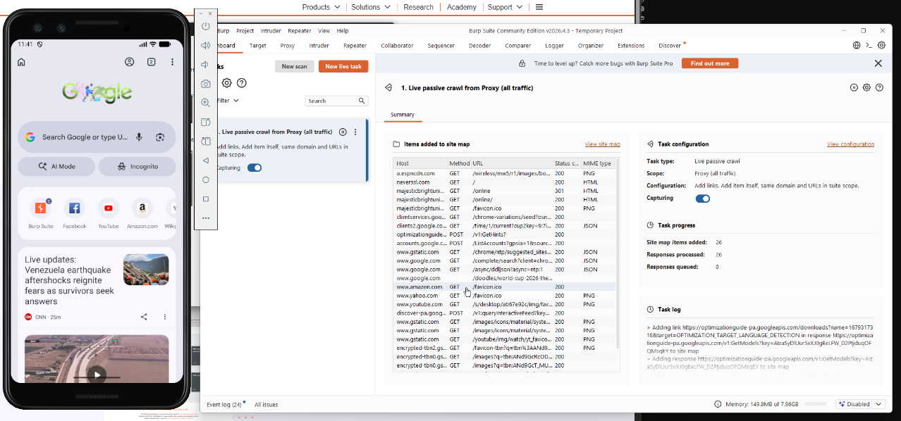

7. Defensive Lessons Learned
Dynamic analysis of transport layer components highlights critical design considerations for mobile development teams:
- HTTPS/TLS is a Non-Negotiable Baseline: All mobile applications must explicitly ban clear text HTTP traffic. Utilizing standard TLS tunnels protects against baseline sniffing attacks, but developers need to understand that transport-layer encryption does not automatically resolve authentication flaws.
- Encryption doesn’t mean Authorization: Encrypting a network request prevents attackers from viewing it in transit, but it does not stop a malicious user from proxying their own data (just like we did in this lab) to modify values, change prices, or manipulate API parameters. Strong server-side validation is still super important.
- Minimize Data Footprints: Applications should minimize the retention and transmission of identifiers, tokens, and verbose error codes within payloads to limit exposure if a proxy boundary is breached.
- The Double-Edged Sword of Certificate Pinning: Implementing strict certificate pinning drastically reduces the risk of reverse engineering and advanced machine-in-the-middle data theft. However, it introduces steep operational overhead. If a server certificate expires or needs an emergency rotation, a pinned application will break globally until a fresh update is pushed through the app store.

8. Required Reflection Questions
- Which captured request or response was the most important, and why?
The cleartext GET request to neverssl.com generating an immediate 301 redirect inside Burp Suite was the most important. It served as our definitive operational baseline, verifying that the ADB global proxy configuration was active and that our host computer's listener was successfully capturing packets.
- What was the most useful tool in this lab: Burp Suite, logcat, Jadx, or another tool? Explain your answer.
Burp Suite was definitely the most useful tool. While ADB was necessary to force the system's routing paths, Burp Suite's HTTP History tracking panel provided the exact visibility required to evaluate incoming headers, track status codes, and examine how parameters change in flight.
- What was the easiest part of configuring interception?
Binding Burp Suite to "All Interfaces" on port 8080 was the easiest part. The graphical user interface in Burp makes modifying proxy listener parameters highly intuitive.
- What was the most difficult part of determining whether the app trusted the Burp certificate?
The most difficult part was navigating the architectural differences between user-installed certificates and system-level root anchors. Distinguishing whether a connection drops because an app actively uses advanced certificate pinning or because it is simply invoking modern Android API security rules requires careful code analysis.
- What evidence would you require before stating that an app uses certificate pinning?
I would require definitive proof from an active source code audit (e.g., locating explicit CertificatePinner objects or OKHttp network configurations in Jadx) or a dynamic instrumentation log showing an explicit public key hash rejection error during a TLS handshake.
- What transport-security improvement would have the greatest benefit for this app?
Enforcing a rigorous, custom server-side validation profile combined with a modern Network Security Configuration file that completely disables cleartext traffic blocks broad-spectrum sniffing attacks completely.

AI Use Statement: Generative AI was utilized to assist in creating an initial outline, as well as formatting the flowchart. All technical analysis, tool execution, and code evaluations were derived directly from hands-on lab work.

